Twitter Engagement Analytics Dashboard
Prepared by: Karina
Internship Domain: Data Analytics
Tools Used: Microsoft Power BI
Dataset: Twitter Analytics Dataset
Organization: ElevanceSkills

Task 1: Tweet Interaction Breakdown by Category

Tweet Interaction Breakdown by Category Create a clustered bar chart that shows the sum of URL clicks, user profile clicks, and hashtag clicks grouped by tweet category such as tweets with media, links, or hashtags. Include only tweets that have at least one of these interaction types. Apply additional conditions where the visualization should only be visible between 3 PM IST and 5 PM IST, and hidden at other times. Also, filter the dataset to include only tweets where the tweet date is an even number and the tweet word count is greater than 40. This task helps analyze how different types of tweets drive user interactions.

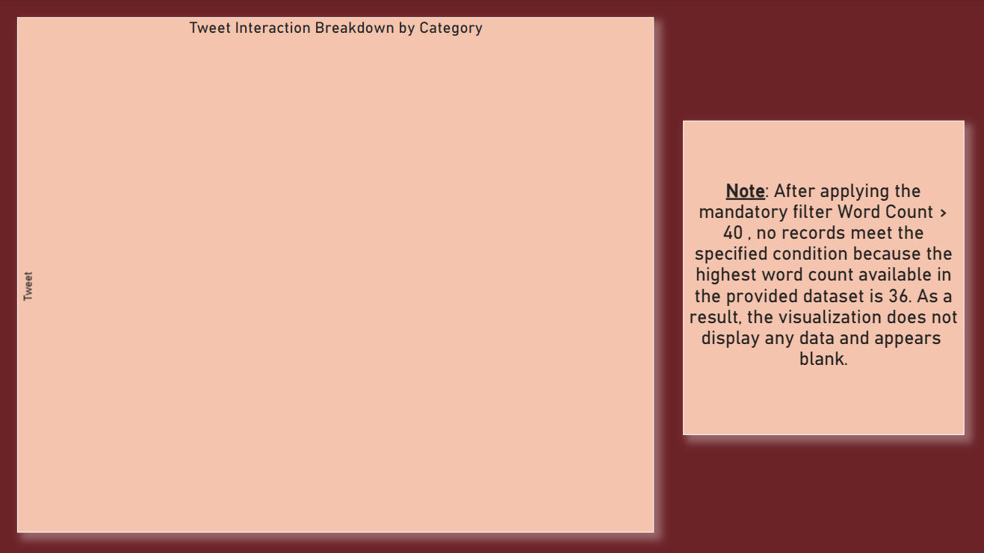

Methodology:
A clustered bar chart was created to compare URL Clicks, Profile Clicks, and Hashtag Clicks across Tweet Categories. The visualization was filtered to include tweets having at least one of the specified interaction types. Additional conditions were applied for even tweet dates, Word Count > 40, and the required 3:00 PM–5:00 PM IST visibility period.
Note:
After applying the mandatory filter Word Count > 40 , no records meet the specified condition because the highest word count available in the provided dataset is 36. As a result, the visualization does not display any data and appears blank.
Task 2: Average of engagement rate by App Opens Category

Engagement Rate Comparison Analyze and compare the engagement rate of tweets that include app opens versus those that do not. Include only tweets posted between 9 AM and 5 PM on weekdays. The visualization should be active only between 12 PM IST to 6 PM IST and 7 AM to 11 AM IST. Apply filters where tweet impressions are even numbers, tweet dates are odd numbers, and tweet character count is above 30. Also, remove tweets that contain the letter ‘D’. This task helps evaluate how app interactions influence engagement rates.

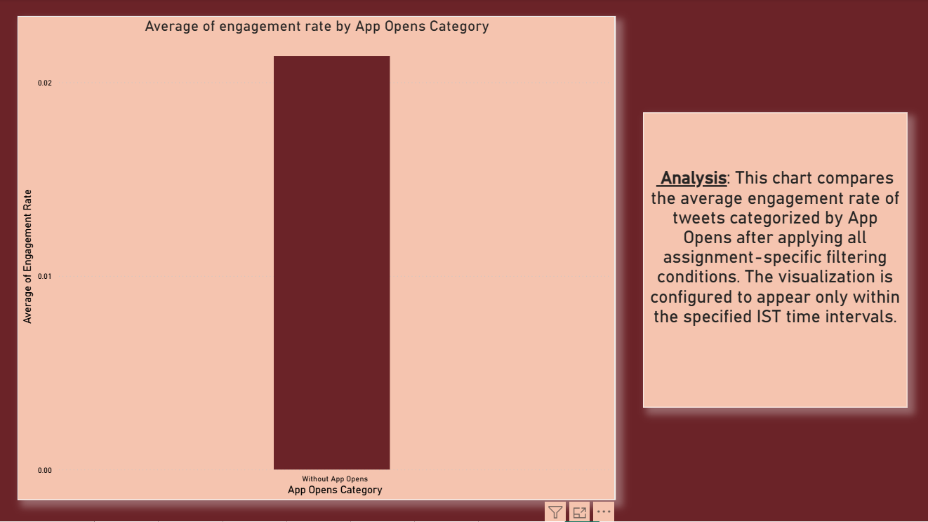

Methodology
A clustered column chart was created with App Opens Category on the X-axis and Average Engagement Rate on the Y-axis. The required filters were applied, including weekday tweets posted between 9:00 AM and 5:00 PM, even impressions, odd tweet dates, character count greater than 30, and exclusion of tweets containing the letter 'D'. A visual visibility measure was also applied for the specified IST time intervals.

Analysis:

This chart compares the average engagement rate of tweets categorized by App Opens after applying all assignment-specific filtering conditions. The visualization is configured to appear only within the specified IST time intervals.

Task 3: Media Views and Media Engagements by Day of the Week (Q4 2020)

Media Interaction by Day of Week Create a dual-axis chart that visualizes both media views and media engagements by day of the week for the last quarter. Highlight days where there are noticeable spikes in interactions. The chart should only be visible between 3 PM IST to 5 PM IST and 7 AM to 11 AM IST. Apply filters such that tweet impressions must be even numbers, tweet dates must be odd numbers, and tweet character count must be above 30. Additionally, exclude tweets that contain the letter ‘H’ in their text. This task focuses on identifying patterns in media engagement across different days.

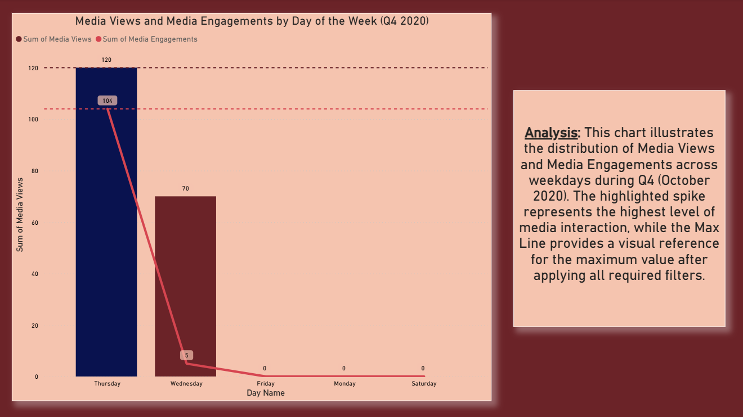

Methodology:
A Line and Clustered Column Chart was created with Day Name as the shared axis, Media Views as the column value, and Media Engagements as the line value. The data was restricted to Q4 (October 2020) and the specified filters were applied for impressions, tweet dates, character count, and exclusion of tweets containing 'H'. A Max Line was added to identify the peak interaction level, and the highest column was highlighted using a contrasting color.

Analysis:

This chart illustrates the distribution of Media Views and Media Engagements across weekdays during Q4 (October 2020). The highlighted spike represents the highest level of media interaction, while the Max Line provides a visual reference for the maximum value after applying all required filters.

Task 4: Sum of Replies, Sum of Likes and Sum of Retweets

Replies, Retweets, and Likes Comparison Develop a simple visualization (bar chart) that compares the number of replies, retweets, and likes for tweets. Add a filter to include only tweets posted between June and August 2020. Use basic aggregation such as SUM for replies, retweets, and likes. This task is beginner-friendly and helps understand overall engagement metrics without complex filtering or logic.

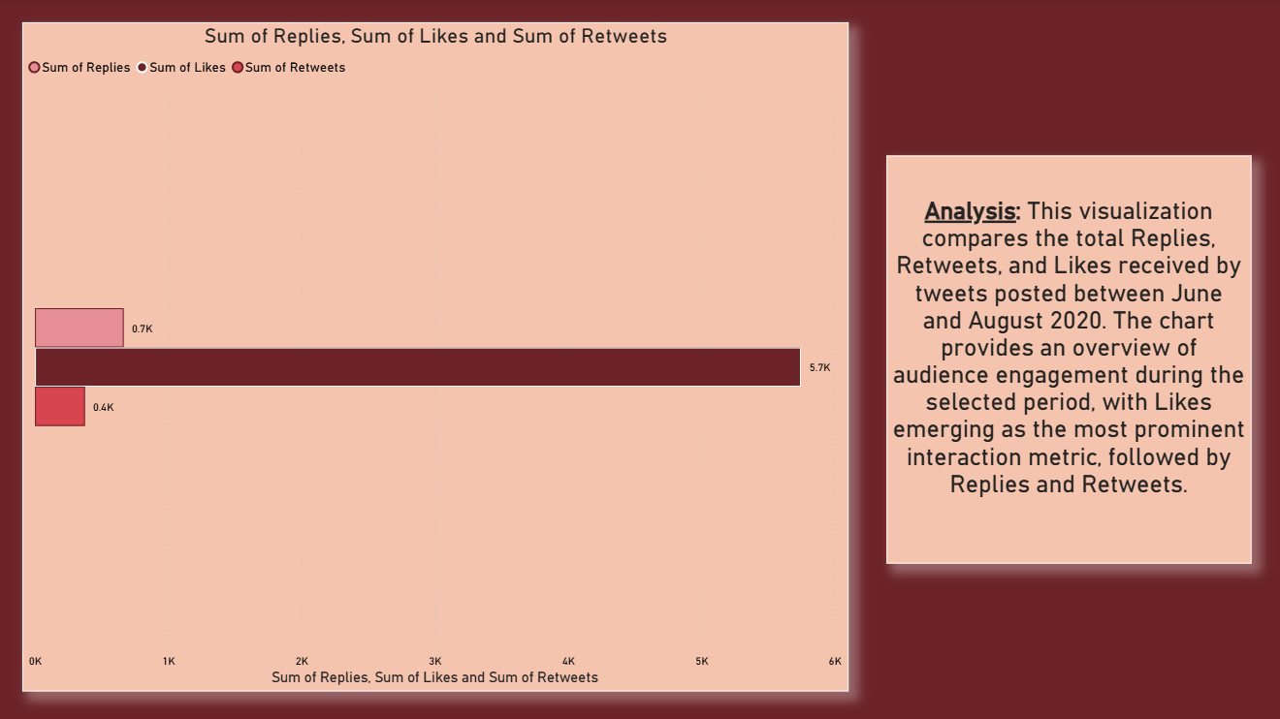

Methodology:
A bar chart was created to compare the total Replies, Retweets, and Likes using the SUM aggregation. A date filter was applied to include tweets posted between June and August 2020.

Analysis:
This visualization compares the total Replies, Retweets, and Likes received by tweets posted between June and August 2020. The chart provides an overview of audience engagement during the selected period, with Likes emerging as the most prominent interaction metric, followed by Replies and Retweets.
Task 5: Monthly Average Engagement Rate Trend by Media Category

Monthly Engagement Rate Trend Create a line chart that shows the trend of average engagement rate for each month of the year. Separate the data into two lines: tweets with media content and tweets without media content. Use month as the time dimension and average engagement rate as the metric. This task is simple and helps beginners understand trends and comparisons over time.

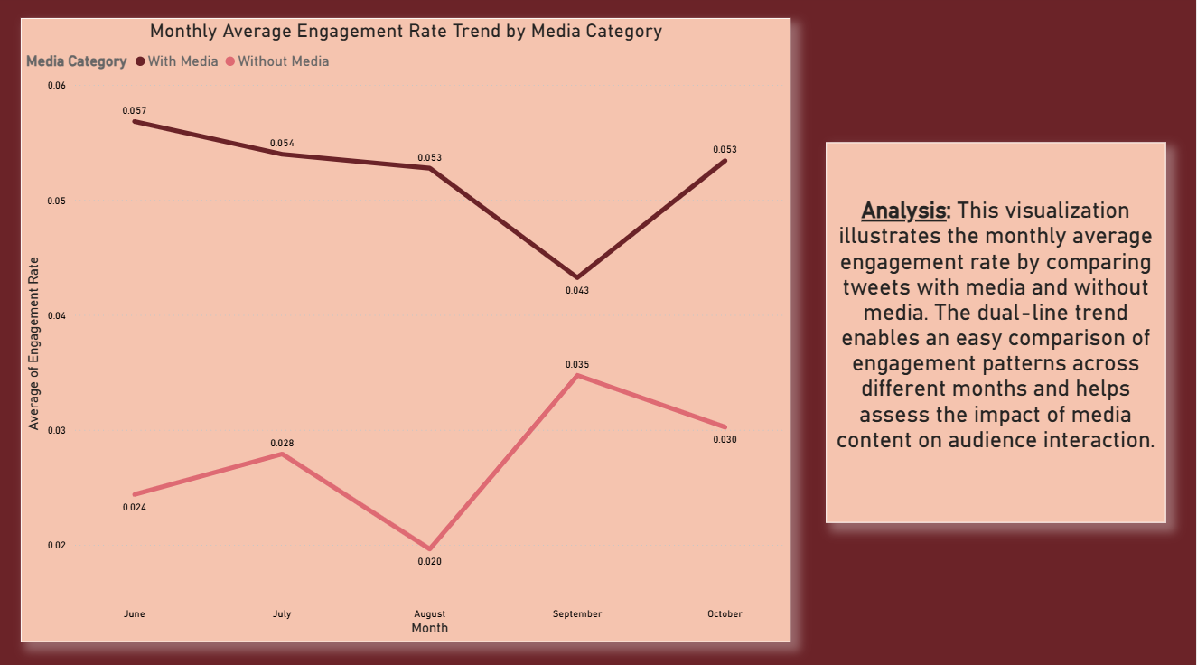

Methodology:
A line chart was created using Month Name as the time dimension and Average Engagement Rate as the metric. The data was divided into two categories based on the presence or absence of media content. A Month Number column was used to maintain the correct chronological order of months.

Analysis:
The visualization shows the monthly trend in average engagement rate and allows comparison between tweets containing media and tweets without media. This helps identify changes in engagement performance across the months.
Task 6: Top 10 Tweets by Retweets and Likes

Top 10 Tweets by Engagement Build a chart to identify the top 10 tweets based on the sum of retweets and likes. Exclude tweets posted on weekends and display the user profile associated with each tweet. The chart should only be visible between 3 PM IST and 5 PM IST. Apply additional filters where tweet impressions must be even numbers, tweet dates must be odd numbers, and tweet word count must be less than 30. This task helps identify high-performing tweets and their creators.

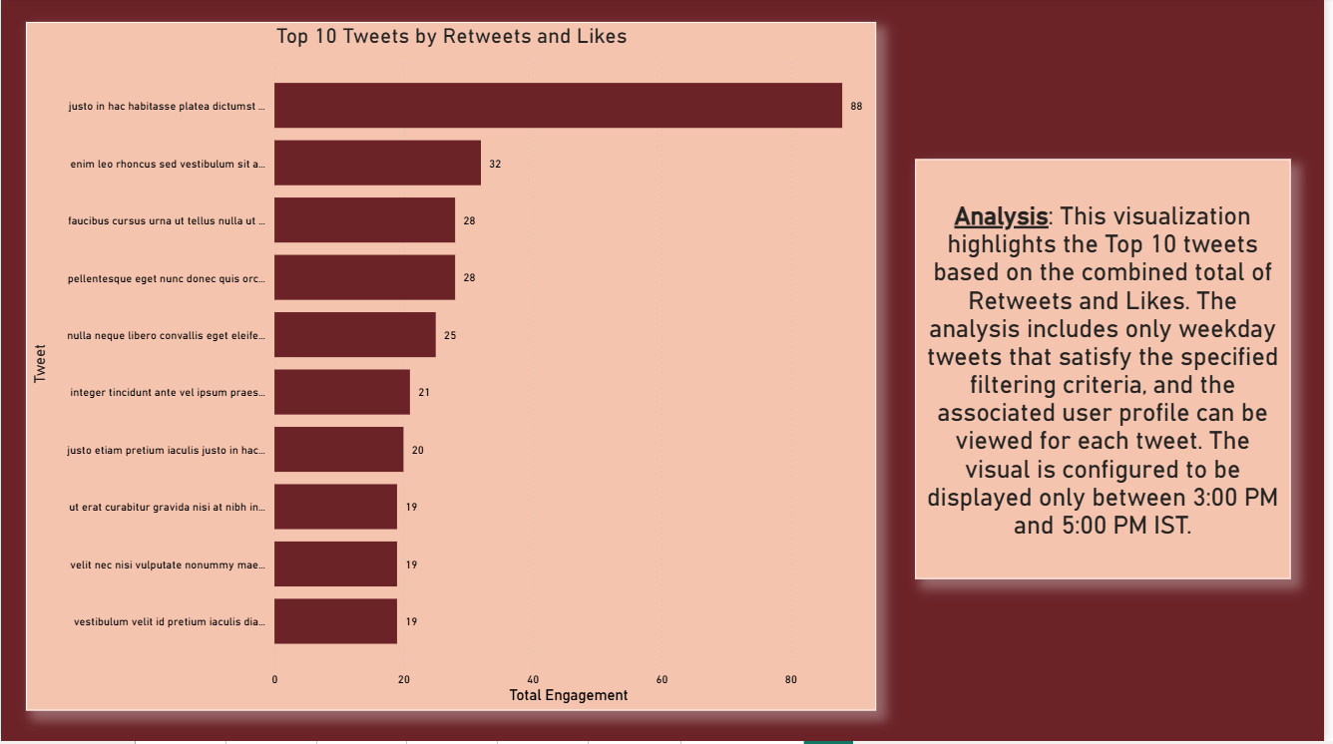

Methodology:
A Total Engagement measure was created by adding Retweets and Likes. A bar chart was then used to rank tweets based on this combined engagement value. A Top 10 filter was applied using Total Engagement as the ranking measure. Weekend tweets were excluded, along with tweets failing the specified impression, date, and Word Count conditions. The visualization was configured to appear only between 3:00 PM and 5:00 PM IST.

Analysis:
This visualization identifies the Top 10 tweets by combined Retweets and Likes, highlighting the tweets that generated the highest level of direct audience interaction after applying the required filters.

